Drag a ListBox into form,
Double click ListBox will pop up ItemsEditor,
You can use ItemsEditor to add, edit or delete ListBoxItem,
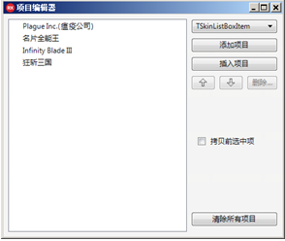
Click button “add” on project editor,
Add some ListBoxItem,
Set the icon and caption of ListBoxItem,
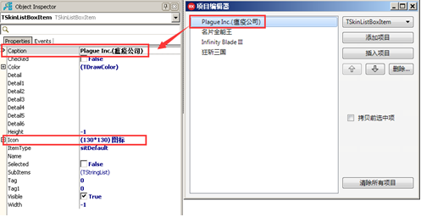
Because of default ListBox doesn’t have its own style,
The icon and caption will be displayed overlapping (caption will be displayed on left top corner by default, icon will be displayed original size also by default).
Like this:
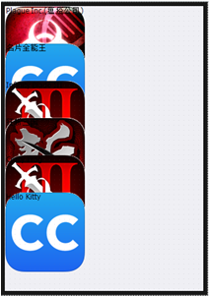
First we adjust icon to make it fit size automatically and vertically centered,
Set DrawItemIconParam.IsAutoFit as True,
Set DrawItemIconParam.PictureVertAlign as pvaCenter,
So the icon won’t be displayed too big.
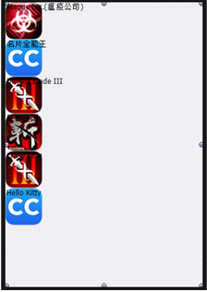
Next we adjust caption to make it displayed on the right of icon, and set the font a little bigger,
Set DrawItemCaption.DrawFont.Size as 14,
Set DrawItemCaption.DrawRectSetting.Enabled as True,
Set DrawItemCaption.DrawRectSetting.SizeType as dpstPixel,
Set DrawItemCaption.DrawRectSetting.Left as 65,
Set DrawItemCaption.DrawRectSetting.Top as 10,
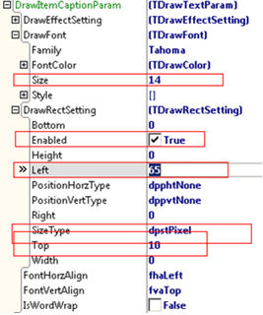
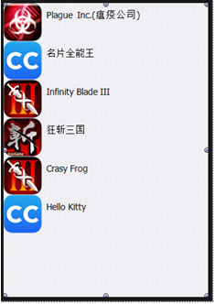
The icon above is too bigger, we need to make it smaller,
Set DrawItemIconParam.DrawRectSetting.Enabled as True,
Set DrawItemIconParam.DrawRectSetting.SizeType as dpstPixel,
Set DrawItemIconParam.DrawRectSetting.Left as 6,
Set DrawItemIconParam.DrawRectSetting.Height as 50,
Set DrawItemIconParam.DrawRectSetting.PositionVertType as dppvtCenter,
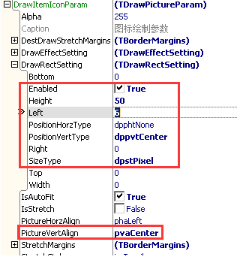
Set background color of ListBox as white,
Set SelfOwnMaterial.IsTransparent as False,
Set SelfOwnMaterial.BackColor.IsFill as True,
Set SelfOwnMaterial.BackColor.FillColor as white,
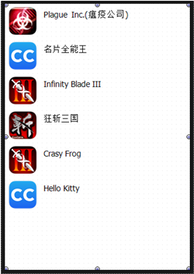
We still have two steps to do,
First we need to add split line between every ListBoxItem,
We only need to set SelfOwnMaterial.DrawItemDevideParam.IsFill as True,
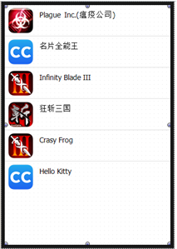
Second when mouse clicking ListBoxItem, the background color will be displayed as light gray,
Find DrawItemBackColorParam.DrawEffectSetting.MouseDownEffect,
Set EffectTypes as drpetFillColorChange and drpetIsFillChange,
Set FillColor as LightGray,
Set IsFill as true,
Try to click mouse when you run it,
