In listbox we can drag ListBoxItem horizontally, and operate in the slid menu,
For example , in the common used email APP, we can delete an email in the slid menu,
Like this:
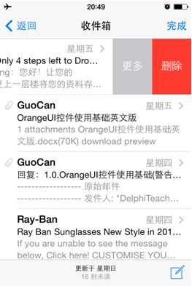
You can complete it by these steps:
Drag a ItemDesignerPanel into ListBox,
Put two buttons on ItemDesignerPanel,
Like this:
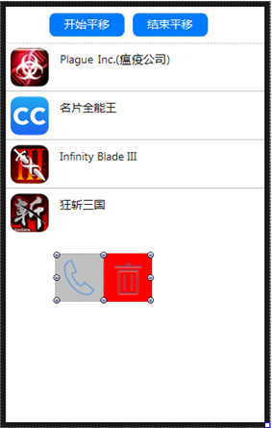
Set ListBox.Properties.ItemPanDragDesignerPanel as this ItemDesignerPanel,
And set ItemPanDragGestureDirection as ipdgdtLeft, it means fingers drag from right to left can slide out ItemDesignerPanel.
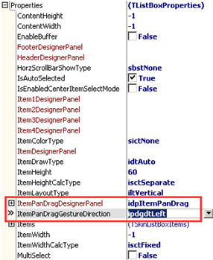
Let’s see the effect:
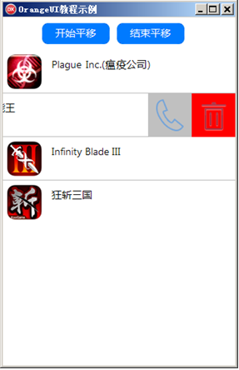
When ItemPanDragGestureDirection is ipdgdtRight, it means fingers drag from left to right can slide out ItemDesignerPanel,
Like this:
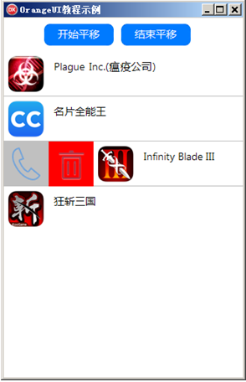
When clicking one button of ItemDerPanesignel , in the button’s OnClick event, we need to call method StopItemPanDrag of ListBox to stop dragging.
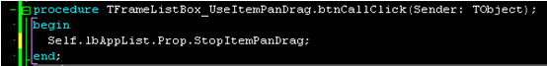
procedure TFrameListBox_UseItemPanDrag.btnCallClick(Sender: TObject);
begin
Self.lbAppList.Prop.StopItemPanDrag;
end;

