Drag a NotifyNumberIcon into form,
Set size as 20*20,
Set its background as common red round,
Set SelfOwnMaterial.IsTransparent as False,
Set SelfOwnMaterial.BackColor’s FillColor as Red,
Set SelfOwnMaterial.BackColor.IsRound as True,
Set RoundWidth and RoundHeight as 10,
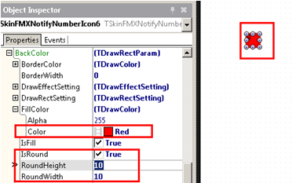
Then set NotifyNumber’s fontColor as white, and make it display center,
Set DrawFont.FontColor.Color of DrawCaptionParam as White,
Set FontHorzAlign as fhaCenter,
Set FontVertAlign as fvaCenter，
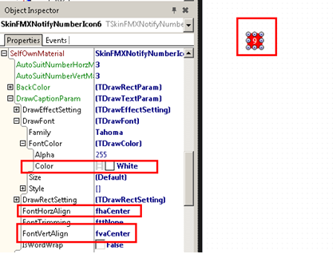
Set over, this is the effect,
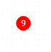
Next ,we will make it not display notification,
Set Properties.NeedNotify as False,
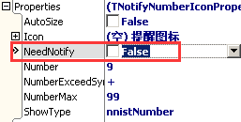
Display like this:
Theoretically, if we set NotifyNumberIcon as not allow to notify,
Its red round background will not display either,
A single red round displayed in interface,
People can’t know what it is used for.
That’s because when we set NotifyNumberIcon’s NeedNotify as False,
The background color is still displayed, but background picture, icon, and number will be hidden,
So, NotifyNumberIcon need to set SelfOwnMaterial.Picture.

