Drag a NotifyNumberIcon into form,
Set size as 40*20,
Set Properties.Number as 9,
Set its background picture SelfOwnMaterial.Picture as ,
Now it looks like this:
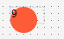,
Then set NotifyNumber’s font color as white, make it display center,
Set DrawCaptionParam’s DrawFont.FontColor.Color as White,
Set FontHorzAlign as fhaCenter,
Set FontVertAlign as fvaCenter，

Now we will introduce property SelfOwnMaterial.IsDrawPictureAutoSuitNumber,
It can draw background picture automatically according to the position of NotifyNumber,
SelfOwnMaterial.IsDrawPictureAutoSuitNumber is checked defaultly,
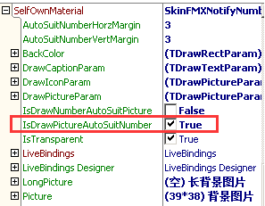
So, when we set NotifyNumber as centered display, position of background picture will centered display too,
Let’s see effect:
We still need to set background stretched display,
Set SelfOwnMaterial.DrawPictureParam.IsStretch as True,
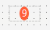,
Because the NotifyNumber has only one digit, so the DrawArea of background is too small, it looks strange.
So we need to adjust autosuit DrawArea,
Property SelfOwnMaterial.AutoSuitNumberHorzMargin is used for setting value of horizontally enlarge,
Property SelfOwnMaterial.AutoSuitNumberVertMargin is used for setting value of vertically enlarge,
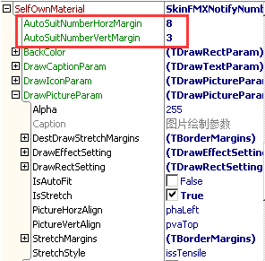
Ok, set over, this is the effect,
,
Next ,set NotifyNumber as 88,
,
Next, set NotifyNumber as 100,
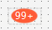
Why I set HelpNumber as 100 but display “99+” not “100”?
That’s because NotifyNumberIcon has a property called NumberMax,
Like this:
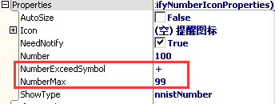
When number is bigger than NumberMax,
Such as Number is 100, NumberMax is 99,
Then it will only display “99+”,
To avoid Number is too big
to be displayed by NotifyNumberIcon.

In last chapter I mentioned, if we set Properties.NeedNotify as False,
It will hide background picture,iocn and number,
Let’s try,
Set Properties.NeedNotify as False,
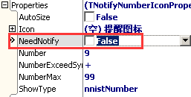
Look effect:
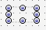
Really there is nothing.

