Usually there is a control on the top of APP’s home page to take turns to play advertisements,
Like this:
Drag a ImageList into form,
Double click Imaglist,
Add these pictures in the popped up picture list editor,
1.
2.
3.
4.
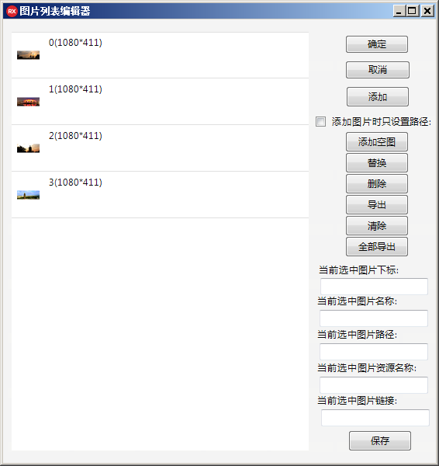
Drag a ImageListViewer into form,
Set its Propertie.Picture.SkinImageList as ImageList before,
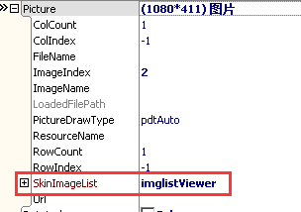
Set Propertie.ImageListAnimated as True,
It means display picture of ImageList circularly switched.
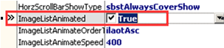
Like this(the picture is switching)：
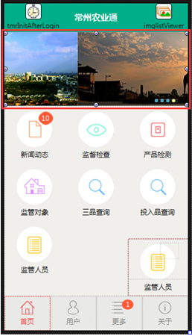
And set whether allow to switch pictures by gestures,
Set Properties.CanGestureSwitch as True,
Like this:
