RoundImage inherits from Image,
It can add a rectangle which can clip round corner rectangle on the basic of Image,
This rectangle is drawn on picture,
To make picture have an effect of being clipped.

Next let me show
How to clip this avatar to a round avatar.
Avatar picture:
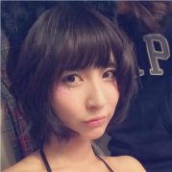

Drag a RoundImage into form,
Set size as 100*100,
Double click Properties.Picture,
Select the avatar picture above in the popped up select picture Dialog Box,
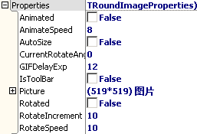
Then set picture’s draw parameters,
Set DrawPictureParam.IsAutoFit as True,
Set DrawPictureParam.IsStretch as True,
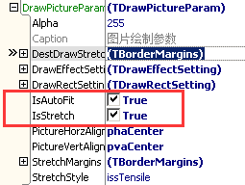
This is the effect:
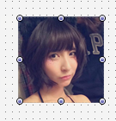
Next set clipped round corner rectangle,
Here are some properties we will use:
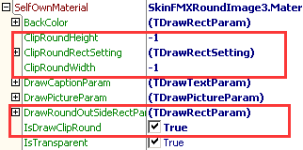
DrawRoundOutSideRectParam: setting of rectangle
IsDrawClipRound: whether clip round corner rectangle
ClipRoundWidth: clip round corner rectangle’s round corner width
ClipRoundHeight: clip round corner rectangle’s round corner height
ClipRoundRectSetting: clip round corner rectangle’s draw rectangle setting
In default situation,
We only need to set DrawRoundOutSideRectParam,
Set DrawRoundOutSideRectParam.FillColor as red,
Set DrawRoundOutSideRectParam.IsFill as True,
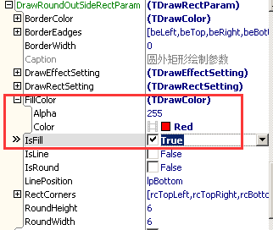
Ok,this is effect:
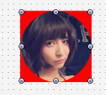
It seems like the avatar is clip to round,
Next introduce ClipRoundWidth and ClipRoundHeight,
If ClipRoundWidth is -1, it means change its width to the half of control’s width automatically,
If ClipRoundHeight is -1, it means change its height to the half of control’s height automatically,
Set RoundImage’s size as 120*100 to see effect,
Like the picture below, because control’s width is 120,so ClipRoundWidth change to 60 automatically,
because control’s height is 100,so ClipRoundHeight change to 50 automatically,
the avatar is clip to an ellipse,
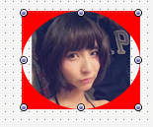
If we need to add the avatar an effect of looking like clip to round corner rectangle,
We only need to assign a special value to ClipRoundWidth and ClipRoundHeight
Here we set them as 10,
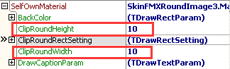
The effect is like this, the four corners of avatar is erased and draw red,
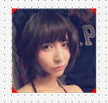
Then add frame to four borders of avatar,
Set ClipRoundRectSetting.Enabled as True,
Set ClipRoundRectSetting.SizeType as dpstPixel,
Set ClipRoundRectSetting.Left,Bottom,Right,Top all as 5,
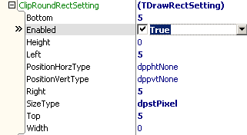
This is the effect:
