Now, let me introduce TRoundRect of FMX,
We can use TRoundRect to make round avatar effect,
For example, if I put a TRoundRect on form,
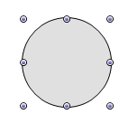
Set its Fill.Kind as Bitmap,
Set Fill.Bitmap.Bitmap as 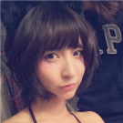,
Set Fill.Bitmap.WrapMode as TileStretch,
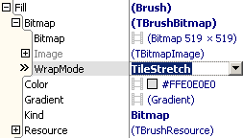
This is the effect:
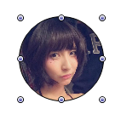
It also can realize the effect of clip picture to round,
So, in normal situation,
We could not use RoundImage,
But use TRoundRect.
Then why do we need a RoundImage,
For example, if I want clip every ListItem’s icon to round in ListBox of OrangUI,
Like this:
If I put a RoundRect on ItemDesignerPanel,
But RoundRect only can load ListItem’s icon to Fill.Bitmap,
But can’t assign reference of ListItem’s icon to Fill.Bitmap,
So in this situation, every time ListBox draw a ListItem,
Need to load ListItem’s icon to RoundRect.Fill.Bitmap,
The code is: RoundRect.Fill.Bitmap.Bitmap.Assign(Item.Icon),
This process takes a lot of time.
To use reference of ListItem’s Icon directly,
We need use RoundImage,
The code is: RoundImage.Properties.Picture.RefPicture:=Item.Icon,
So, use RoundImage is efficient.
Next, I will show how to use RoundImage in ListBox,
First prepare a ListBox like this:
Drag a RoundImage into ItemDesignerPanel ,
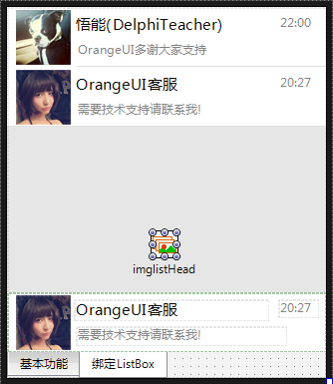
We need to make every ListItem’s avatar have the effect of clip to round,
We only need set DrawRoundOutSideRectParam of RoundImage,
Set DrawRoundOutSideRectParam.FillColor as white,
Set DrawRoundOutSideRectParam.IsFill as True,
This is the effect:
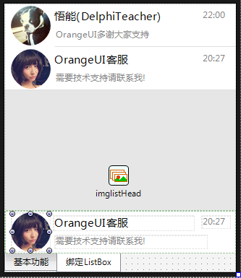
The avatar looks like to be clip to round,
Run to see effect:
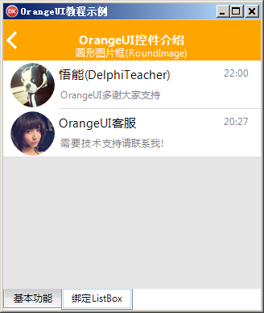
Click the second ListItem,
Find the ListItem’s background turn to gray,
But the four corners of avatar is still white,
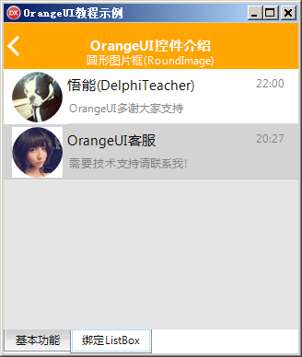
We need to set the click effect of RoundImage,
To make RounImage turn to gray when clicking it,
In SelfOwnMaterial.DrawRoundOutSideRectParam.DrawEffectSetting.MouseDownEffect,
Check drpetFillColorChange of EffectTypes,
Set FillColor as LightGray,
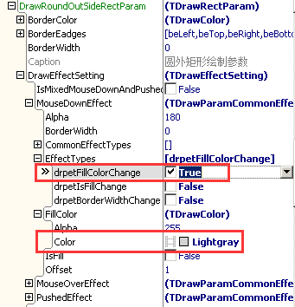
Next , run it,
Click the second ListItem to see effect,
