Drag a ImageList into form,
Double click ImageList,
Add these pictures in the popped up picture list editor,
4.
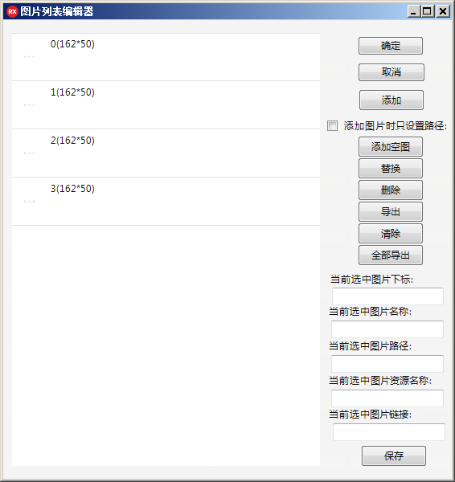
Drag a ImageListPlayer into form,
Set its Propertie.Picture.SkinImageList as ImageList before,
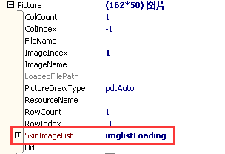
Set Propertie.ImageListAnimated as True,
It means display picture of ImageList circularly switched.
Set Propertie.AutoSize as True,
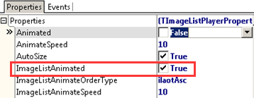
So the picture will keep circularly switched displaying:

